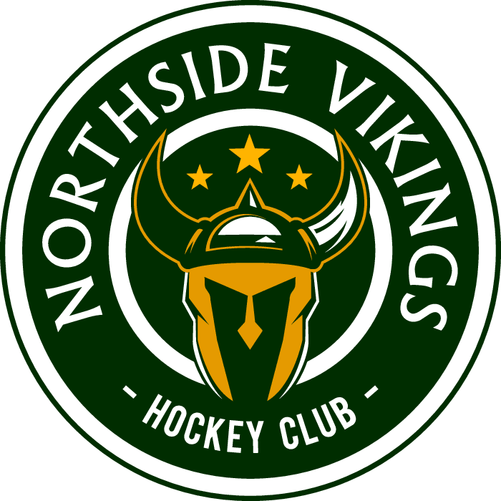NORTHSIDE & DISTRICT MINOR HOCKEY ASSOCIATION COACHES APPLICATION 2023-2024
Name:
Address:
Email Address:
Birth Date (dd/mm/yr.)
Team Choice Representative or Recreational League (circle one) Contact Number _______________

Division (U7) _____ (U9)____ (U11) ____ (U13) _____ (U15) ___ (U18) _____ Please specify what level AA, A, B or C _____________________ Head Coach or Assistant Coach _____________________
Details: Children Playing in Division Choice Yes or No
Coaching / Trainer / Manager Experience Last Team Name ______________________________ Year _______________ Level ______________________________ Previous Teams Name ______________________________ Year _______________ Level ______________________________ Name ______________________________ Year _______________ Level ______________________________
Training Levels National Coaches Certification Program Current Level ______________________ Number ____________ Year Attended ___________ Trainers Certification Program Current Level ______________________ Number ____________ Year Attended ___________
NSDMH ASSOCIATION Respect in Sport – Activity Leader Year Completed __________________ Communication_______________________________________________________________ References Name ______________________________ Telephone # ________________ Name ______________________________ Telephone # ________________
I certify that the above information represents an accurate description of my qualifications. As a coach / trainer or volunteer of any rep team or Rec league team I will seek and attain the proper training required by the Canadian Amateur Hockey Association and ensure that every member of the teams’ volunteer staff is trained appropriately. If accepted as a coach / trainer or volunteer of any NSDMH Association team, I will know and understand the association rules of fair play and treatment of players. I will maintain an inclusive dressing room that adheres to HNS maltreatment rules. I understand if accepted as a coach / trainer or volunteer of any NORTHSIDE & DISTRICT MINOR HOCKEY Association team I am required to have a Criminal Record & Vulnerable Sector completed at my local Policing office. These records will be kept in a confidential file only viewed by select NSDMH executives.
Signature ______________________________ Date ____________________
Please return all applications to Northside & District Minor Hockey Association. Applications may be delivered by hand to the Office at the Emera Centre, or emailed to nsminorhockey@bellaliant.com

